**Muhammad Tanzil-UR-Rehman**

**BCS211037**

**Section 01**

**Lab 8**

**Example**

.model small

.data

num1 db ?

.code

mov ax,@data

mov ds,ax

mov cx,5

mov si,0

l2:

mov ah,01

int 21h

mov [num1+si],al

sub [num1+si],48

inc si

loop l2

mov cx,5

mov si,0

l1:

mov bl,[num1+si]

inc si

mov dl,bl

add dl,48

mov ah,02

int 21h

loop l1

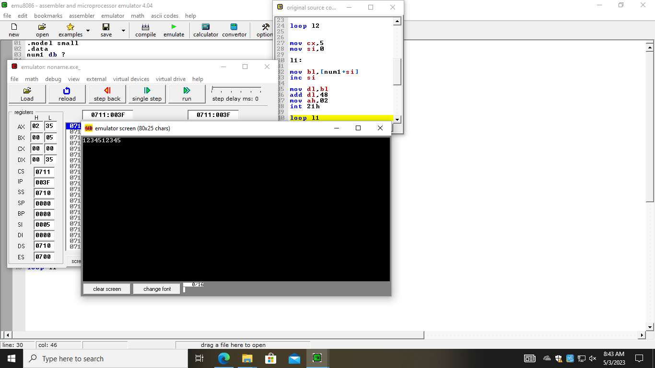

**Walkthrough task 01**

.model small

.data

num db 5,2,5,6,1,32,6

max db 0

.code

mov ax,@data

mov ds,ax

mov ax,0

mov al,[num+0]

mov max,0

mov cx,6

mov si,0

l1:

cmp [num+si],al

jg gg

jmp e

gg:

mov al,[num+si]

mov max,al

e:

inc si

loop l1

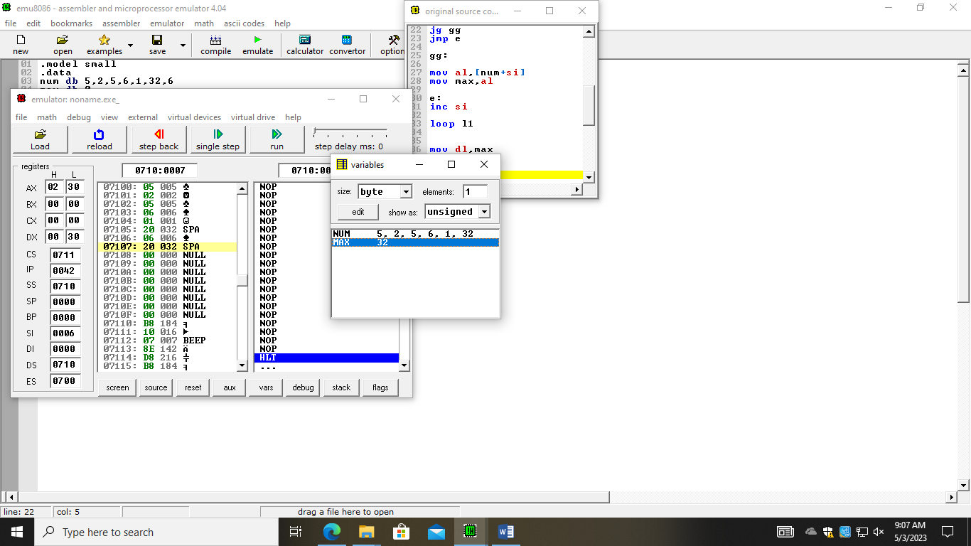

**Practice task 01**

.model small

.data

inp db "Enter 10 numbers: $"

outpt db 0ah,0dh," maximum : $"

outp2 db 0ah,0dh,"minimum : $"

num1 db ?

max db 0

min db 0

.code

mov ax,@data

mov ds,ax

mov cx,10

mov si,0

l1:

mov ah,01

int 21h

mov [num1+si],al

sub [num1+si],48

inc si

loop l1

mov ax,0

mov al,[num1+0]

mov max,0

mov si,0

mov cx,10

l2:

cmp [num1+si], al

ja gg

jmp e

gg:

mov al,[num1+si]

mov max,al

e:

inc si

loop l2

lea dx,outpt

mov ah,09

int 21h

mov dl,max

add dl,48

mov ah,02

int 21h

mov ax,0

mov al,[num1+0]

mov min,0

mov si,0

mov cx,10

l3:

cmp [num1+si], al

jng gf

jmp a

gf:

mov al,[num1+si]

mov min,al

a:

inc si

loop l3

lea dx,outp2

mov ah,09

int 21h

mov dl,min

add dl,48

mov ah,02

int 21h

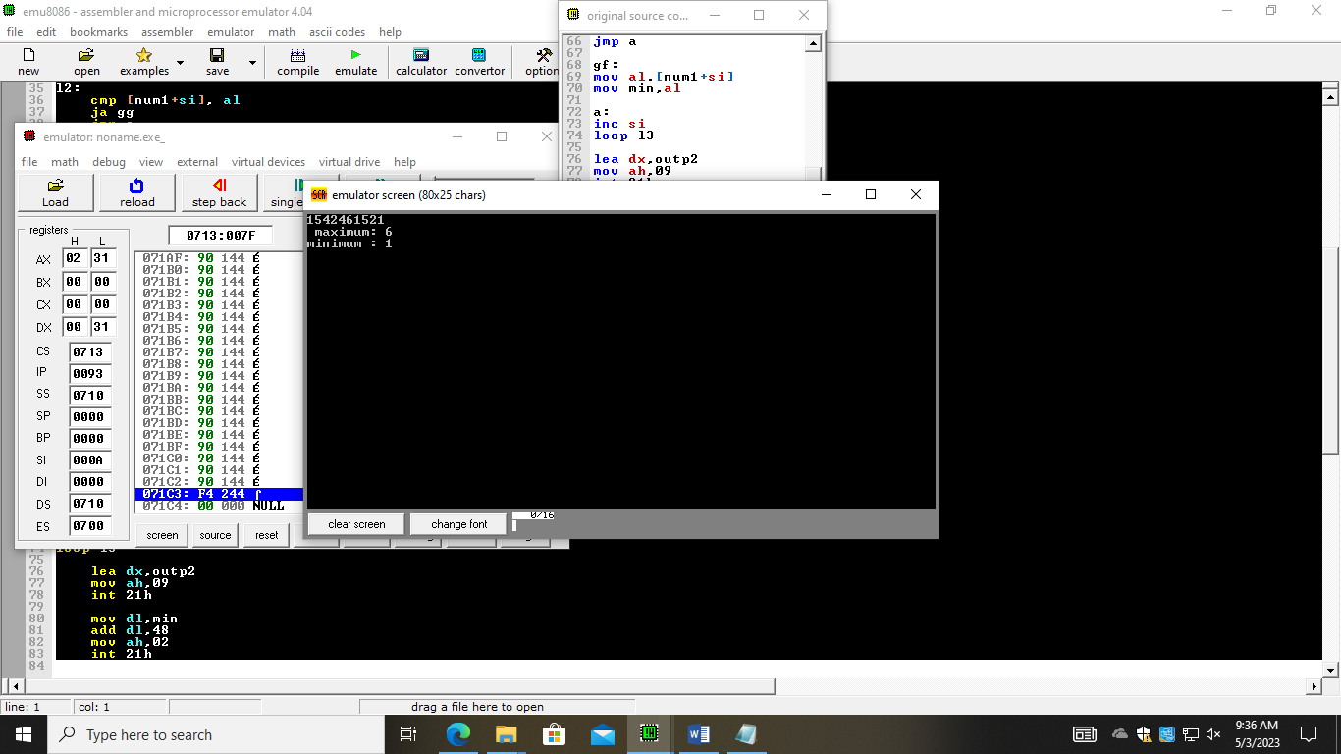

**Practice task 02**

.model small

.data

input db "Enter numbers: $"

odd db 0ah,0dh,"ODD NUMBER COUNT :::: $"

even db 0ah,0dh,"EVEN NUMBER COUNT : $"

oc db 0

ce db 0

num1 db ?

.code

mov ax,@data

mov ds,ax

mov cx,5

mov si,0

lea dx,input

mov ah,09

int 21h

l1:

mov ah,01

int 21h

mov [num1+si],al

sub [num1+si],48

inc si

loop l1

mov cx,5

mov si,0

ca:

mov ax,0

mov al,[num1+si]

mov bl,2

div bl

cmp ah,0

jne j1

jmp j2

j1:

add oc,1

jmp e

j2:

add ce,1

e:

inc si

loop ca

lea dx,odd

mov ah,09

int 21h

mov dl,oc

add dl,48

mov ah,02

int 21h

lea dx,even

mov ah,09

int 21h

mov dl,ce

add dl,48

mov ah,02

int 21h

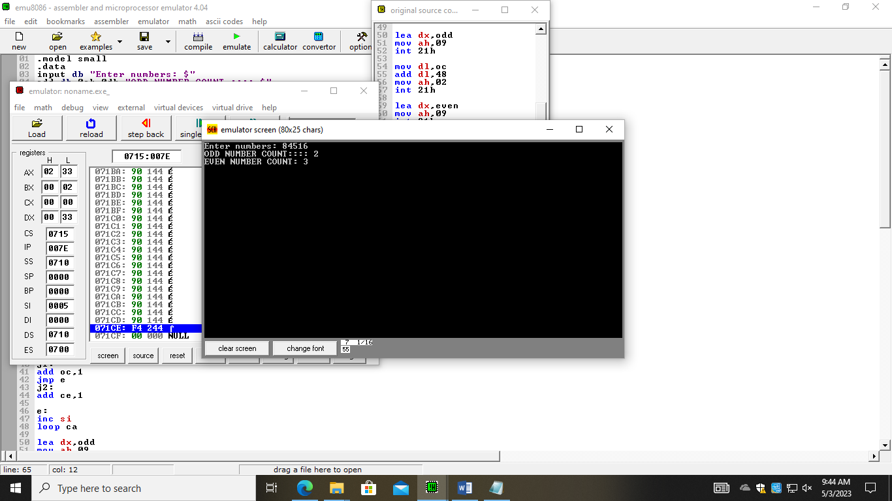

**Practice task 03**

.model small

.data

str1 db 0ah,0dh,"Enter Any Number for index $"

str2 db ": $"

space db 0ah,0dh,"$"

str3 db 0ah,0dh,"Element $"

str4 db " of Array : $"

var1 db ?

num1 db ?

.code

main proc

mov ax,@data

mov ds,ax

mov si,0

mov cx,10

mov var1,0

add var1,48

l1:

lea dx,str1

mov ah,09

int 21h

lea dx,str2

mov ah,09

int 21h

mov ah,01

int 21h

mov [num1+si],al

inc si

inc var1

loop l1

lea dx,space

mov ah,09

int 21h

mov cx,10

l2:

dec si

dec var1

lea dx,str3

mov ah,09

int 21h

mov dl,var1

mov ah,02

int 21h

lea dx,str4

mov ah,09

int 21h

mov bl,[num1+si]

mov dl,bl

mov ah,02

int 21h

loop l2

end main

